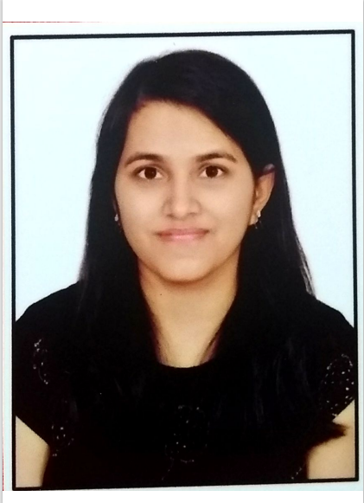

**PRAGYA SINGH**

Course : M.TECH, VLSI, 2024

Email : pragyasinghanku@gmail.com

Mobile : 9752688338

CGPA : 8.3

|  |  |  |  |  |  |
| --- | --- | --- | --- | --- | --- |
| **ACADEMIC DETAILS** | | | | | |
| **COUSRE** | **SPECIALIZATION** | **INSTITUTE / COLLAGE** | **BOARD / UNIVERSITY** | **SCORE** | **YEAR** |
| UG | ELECTRICAL | Shri Shankaracharya Group of Institutions | CHHATTISGARH SWAMI VIVEKANAND TECHNICAL UNIVERSITY | 7.79 | 2021 |
| CLASS XII | SCIENCE | DAV PUBLIC SCHOOL,HUDCO CHHATTISGARH | Central Board of Secondary Education | 61.6% | 2017 |
| CLASS X |  | DAV PUBLIC SCHOOL,HUDCO,CHHATTISGARH | Central Board of Secondary Education | 8.4  CGPA | 2015 |

|  |  |
| --- | --- |
| **Subject Knowledge** | Digital Logic Design, Digital IC Design, CAD for VLSI, Computer Architecture, ASIC Design, Verification Methodology, VLSI Testing and Testability, Low Power IC, IC Technology |
| **Skills** | Verilog HDL, C Programming, Physical design(basic), STA, Perl |
| **Tool and Technology** | ModelSim, Quartus Prime, TCAD Synopsis, LTspice |

|  |
| --- |
| **Academic Projects** |
| **• Designing of Digital Alarm Clock**  Tool used : Xilinx- VIVADO(FEB 23)   1. We are generating a clock with 7 output signals including Alarm signal, Hour, Minute, and seconds 2. The clock generated is in a 24 - hour format. We can give an initial time value to the system when reset signal=1 or by turning the signal LD_time=1   •**:Design & layout of 2 stage Operational Transconducatnce Amplifier**  **Tool used :** LTSPICE (DEC2022 – JAN2023)   1. Implemented the design of a 2-stage fully differential input & single-ended output. 2. Achieved tight specification on DC gain, phase&Gain margin.   3) Implemented its layout in Ltspice with scl 180nm technology. |

|  |
| --- |
| **INTENSHIP- MAVEN SILICON (JAN 203- FEB2023)**  DESIGING AND VERIFICATION |
| * Application of digital electronics in chip designing * Learnt how to design AHP to APB Bridge * Learnt how to develop RTL synthesis, check the elaborated design and simulation to see the working of alarm clock specification and AHP TO APB Bridge protocol * Tools – Xilinx- VIVADO |

|  |
| --- |
| **Languages known** |
| ENGLISH, HINDI |